**Scenario Channels Database**

**\* Identify Entities and Attributes \***

**1- Channels Contains many Movies**

* **Channel_Frequency (Primary Key)**
* **Channel_Name**

**2- Movies Contains many Actors**

* **Movie_Name (Primary Key)**
* **Release_Date**

**3- Directors create many Movies**

* **ProfileID (Primary Key)**
* **D_Name**
* **D_Birthdate**
* **D_Nationality**

**4- Actors Enrolled in Movie**

* **ActorID (Primary Key)**
* **A_Name**
* **A_Nationality**
* **A_Birthdate**

**5- Contract Assigned by one Director**

* **ContractID (Primary Key)**
* **Start_Date**
* **End_Date**
* **ProfileID (Foreign Key)**

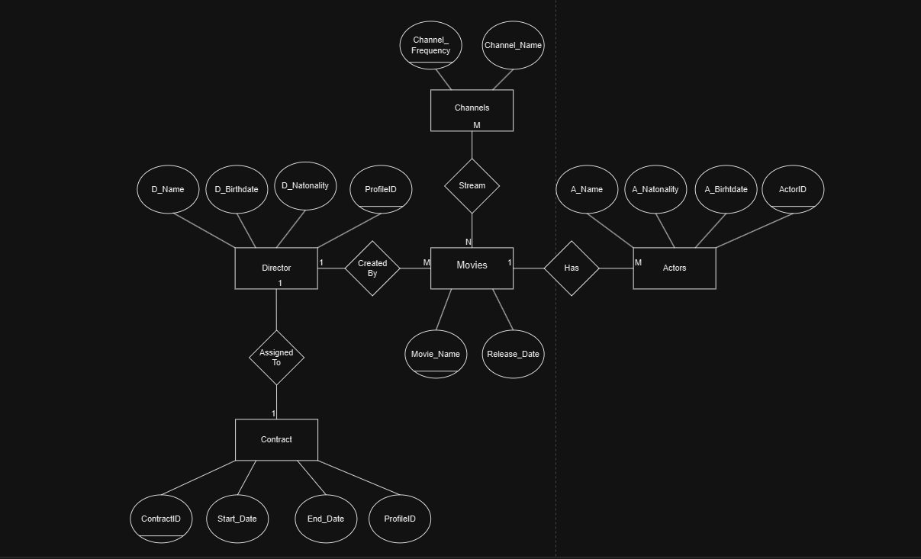**\* Scenario To ER Diagram \***

* Tables *

Create table Channels (Channel_Frequency, Channel_Name)

Create table Movies (movie_Name, Release_Date)

Create table Stream (movie_Name, Channel_Frequency)

Create table Actors (ActorID, A_Name, A_Nationality, A_Birthdate)

Create table Director (ProfileID, D_Name, D_Nationality, D_Birthdate)

Create table Contract (ContractID, Start_Date, End_Date, ProfileID)

**Primary Keys (Channel_Frequency, movie_Name, ActorID, ProfileID, ContractID)**

**FOREIGN KEY (ProfileID Ref Director, Channel_Frequency Ref Channels, movie_Name Ref Movies)**

Tareq Abu Khashabeh 202210295